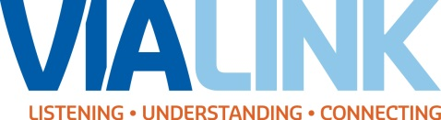
VIA LINK
Is Proud to Sponsor
ASIST
Applied Suicide Intervention Skills Training
A two-day suicide first-aid interactive workshop for
community caregivers
Learn how to:
- Recognize invitations for help
- Reach out and offer support
- Review the risk of suicide
- Apply a suicide intervention model
- Create a quality Safeplan
- Link people with community resources

ASIST is a two-day intensive, interactive and practice-dominated course designed to help caregivers recognize risk and learn how to intervene to prevent the immediate risk of suicide.
ASIST is designed to help all caregivers become more willing, ready and able to help persons at risk. Suicide can be prevented with the help of prepared caregivers.
To inquire or register, please email:
Victoria Schwandt at vschwandt@vialink.org OR
Melanie Moulder at mmoulder@vialink.org
To learn more about ASIST, please visist LivingWorks Wesbite at http://livingworks.net
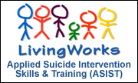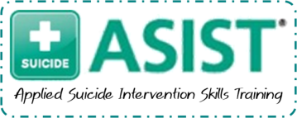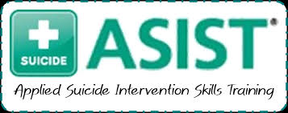
- VIA LINK is providing ASIST to the community at a competitive price for just $170 per participant OR $150 for participant in a guaranteed group of at least 15 individuals (with a max of 30)
- ASIST can be hosted at our agency or the 2-day workshop can be brought to you!
- Workshops can be scheduled once a minimum of 8 individuals register. Specific workshop dates can be scheduled for groups of 15 or more.

